WBC Remote Learning
(Learning at home)

There will be three main ways to learn at home:
1. Live Lessons
2. Independent Learning Assignments
3. BKSB online

1. Live lessons:
A team of staff will be delivering lessons to Year groups using Microsoft Teams.
We will provide a timetable and you will receive an invitation to your lessons.
These will come to your email and you can access the lesson using your calendar or the Teams app.
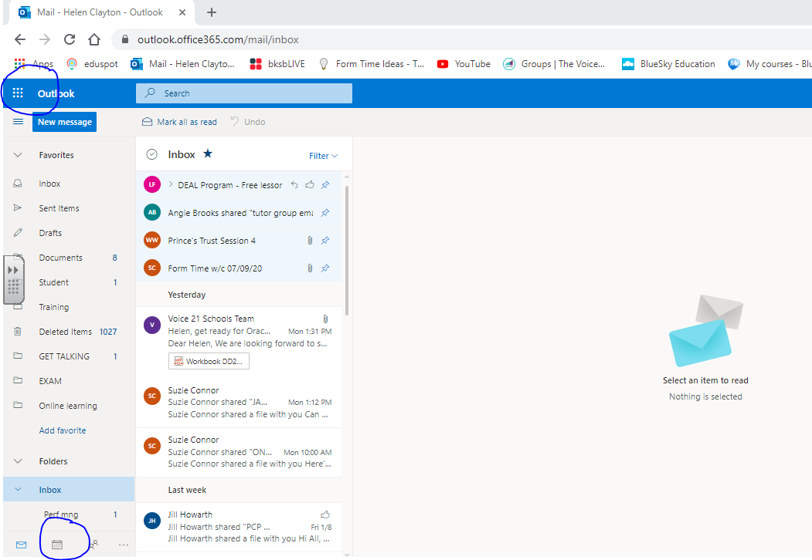
In your emails, click on either of the circled symbols to access your Teams lessons. You just need to ‘Join’ at the right time.

Lesson Expectations
- Please be on time. It’s difficult for everyone if we all arrive at different times and get confused by what’s going on.
- Please have a pen/pencil and some paper ready. (If you do not have either, you could use a memo or note on your phone.)
- Please keep your mic on mute and your camera off, unless asked otherwise by the teacher.
- If you are asked to contribute: Keep it appropriate, kind and relevant! This also applies to written comments in the chat.
Any inappropriate comments may lead to your removal from the lesson and the Teams record can be shared with parents. All lessons are recorded.
2. Independent Assignments
A weekly assignment for English, Maths and Creative studies will be uploaded to Teams.
You just need to open it by clicking on it in the ‘Assignments’ tab, complete it and submit it to either:
MATHS - a.brooks@tprs.tameside.sch.uk
ENGLISH – h.clayton@tprs.tameside.sch.uk
CREATIVE – s.connor@tprs.tameside.sch.uk
You will receive feedback for your work.
3. BKSB
This is our on-line system that generates mini lessons, tasks and tests based on your specific needs and progress. It is VITAL that you use it. You should have used it already in school.
You can use it by going to:
https://whitebridgecollege.bksblive2.co.uk
You will be asked for a username and password. This should have been shared with you by tutors.
Students just have to click on the courses that appear:
-FOCUS Functional Skills
-Maths or English (make sure you choose REFORMS)
Select a topic/course by clicking on the individual links and complete the tasks.
The courses and tasks nearest the top are the ones that you need to work on the most.

WHAT IF IT ALL GOES WRONG?
Your first contact should be your TUTOR, via email.
11-1 - l.riley@tprs.tameside.sch.uk and m.teasdale@tprs.tameside.sch.uk
11-2 - a.rust@tprs.tameside.sch.uk and a.brooks@tprs.tameside.sch.uk
11-3 - s.glover@tprs.tameside.sch.uk
10-5 - s.bigwood@tprs.tameside.sch.uk and k.power@tprs.tameside.sch.uk
10-6 - c.jones@tprs.tameside.sch.uk and h.clayton@tprs.tameside.sch.uk
10-7 - m.khan@tprs.tameside.sch.uk and g.corner@tprs.tameside.sch.uk
10-8 - s.owen@tprs.tameside.sch.uk

