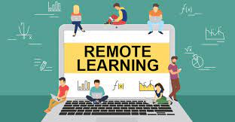
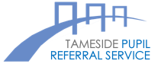
Remote Learning
Student Expectations
Pupils are expected to uphold the following expectations for Remote Learning:

I will:

✓ Arrive on time to all my online lessons, following the schedule and log-in details provided by school.

✓ Ensure that I have all my equipment ready before the lesson starts.

✓ Keep my camera / web cam turned off at all times during lessons unless my teacher asks me to turn it on.

✓ Under no circumstances record the lesson, or share any images from the lesson on any platform.

✓ Keep my microphone muted unless the teacher asks me to speak, and mute myself when I have finished.

✓ Only use the ‘chat’ function if directed to by a teacher / staff member, and only for the purpose they specify.

✓ Ensure that I use appropriate, respectful language when communicating verbally or digitally.

✓ Stay focused on my lesson and ready to contribute my thinking at any point.

✓ Use the ‘raise my hand’ function in order to ask or answer a question.

✓ Gain permission from the teacher if I need to leave the lesson for any reason.

✓ Behave in sensible, kind and courteous way throughout the lesson.

✓ Follow instructions promptly.

✓ Complete tasks to the best of my ability.

✓ Be a positive role model as a member of my school

