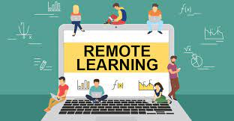
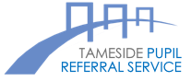
Remote Learning
Parent/Carer Agreement
For Parent / Carers
- When pupils are learning remotely, they are joining ‘live’ lessons.
- Their teachers may be streaming the lesson from school or from another location, depending on the circumstances.
- Our expectation is that pupils continue to follow the full academic curriculum, attending lessons every day and participating fully.
- We expect pupils to behave respectfully and to apply themselves to their studies.
- We value your support in ensuring that your child learns safely and helps to keep others safe.
Parents are expected to uphold the following principles:
As a parent/carer I will:
✓ Ensure, as far as possible, that my child can access their online lessons in a quiet environment.
✓ Support my child’s personal organisation so that they attend lessons punctually, in accordance
with their timetable.
✓ Encourage my child to participate fully in online lessons and to complete independent work set
by the teachers.
✓ Ensure that no element of an online lesson is recorded by my child, family members or myself.
✓ Avoid making any comments, or sharing any material, on social media that could identify my
child, their school or staff.
✓ Ensure that my child takes care of any equipment that they have been loaned by the school and
uses it only for the intended purposes.
✓ Report any concerns that I have about my child’s learning with appropriate staff at the school.

